Federal University Of Technology, Minna
School of Electrical Engineering And Technology
Department of Mechatronics Engineering

Title: Design and Implementation of an Intelligent Irrigation System

By Group 5
September 2025

TABLE OF CONTENT

Abstract .............................................................. 1

Introduction ......................................................... 1
1.1 Objectives ...................................................... 1

Literature Review .................................................. 1-2

System Design and Methodology .......................... 3
3.1 Methods ......................................................... 3
3.2 Methodology .................................................. 4
3.2.1 Automation Using Sensors
3.2.2 Integration with Blynk Web Platform
3.2.3 Machine Learning Component (Conceptual Extension)

Results and Discussion ........................................ 6

Limitations .......................................................... 7

Conclusion .......................................................... 8

References ......................................................... 9

ABSTRACT
The aim of this project was to develop an IoT-enabled water irrigation system for irrigation purposes. Water supply is automated by controlling the soil and water parameters on an immediate-time basis. Through the integration of soil moisture sensors and tank water-level sensors with an ESP32 microcontroller and a relay pump, the system irrigates only when necessary (Yahide, Jain, & Giri, 2015; Oussama et al., 2022). Sensor data are sent to a web-based dashboard for remote inspection and control using Wi-Fi communication (Rafi & Handaga, 2021). Prototype testing proved that the pump operated when moisture level was low and kept off when there was no irrigation needed; this was attested as the system properly took care of automation and monitoring, although some shortcomings have been noted with sensor accuracy and scalability in the field. This work shows the potential of IoT and WSN technologies to improve efficiency of water usage in the field of agriculture, and especially for the farming sector in Nigeria where water management serves an important role (Aguzzi et al., 2021; Archibong, Njok, & Osang, 2025).

1. INTRODUCTION
Agriculture uses about 75% of freshwater globally and suffers from problems of water shortage (Ahmed et al., 2023). Traditional irrigation methods waste a great deal of water by applying it uniformly without considering the needs of a given crop. Efficient irrigation is very important in water-stressed countries such as Nigeria. Nigeria, with large arable land, yet suffers from hunger and low productivity due partly to erratic weather and poor water management (Archibong, Njok, & Osang, 2025). Understood to be one of the options towards solving it, smart irrigation offers “the right amount of water, at the right time, and place” based on sensing and automation (Ahmed et al., 2023). Considering further that sensor networks and IoT enable a smart system to continuously measure soil moisture and enable automatic pump operation to ensure water saving mechanisms toward increasing crop yields (Yahide, Jain, & Giri, 2015); in this regard, an intelligent irrigation system will go a long way toward bringing enormous improvement in efficiency and crop production in Nigerian Agriculture.

1.1 Objectives

The objectives of this project are to:
i. Automate irrigation by monitoring soil moisture and water-tank level, so water is supplied only when the soil is dry and water is available.
ii. Enable remote monitoring and control using a Wi-Fi microcontroller (ESP32) and a web-based dashboard (Blynk), allowing users to track soil moisture, tank level, and pump status in real time (Rafi & Handaga, 2021).
iii. Optimize using Machine Learning to improve decision-making over time.

2. LITERATURE REVIEW
Yahide et al. (2015) studied various web irrigation systems through the wireless sensor network approach, revealing a setup for drip irrigation automation through sensors and actuators. Their system had soil moisture, temperature, and humidity sensors giving inputs to a microcontroller, which then actuated solenoid valves to water the plants. To add to its uniqueness, the system had a web interface for remote control, whereby subscribers need not guess how to schedule irrigation.

Oussama et al. (2022) have looked at irrigation optimization using WSNs. The monitoring of water pipelines was done with WSNs to reveal leakages and reduce energy consumption. Using ZigBee-based communication to conserve power for the sensor nodes, their study demonstrated how WSNs can be successfully applied to precision irrigation.

Rafi and Handaga (2021) developed an IoT controller using ESP32 and Blynk application software. While it was used in a smart-home application, the design principles of ESP32 using Wi-Fi for control
and Blynk for monitoring can also be adapted for irrigation. This study, in combination with the others, has given proof for the low-cost IoT platform in scalable device control.

3. SYSTEM DESIGN AND METHODOLOGY

3.1 Methods
The project made use of the following components:
- ESP32 Microcontroller – is the control unit. Collected data from the sensors , processed the data and connected to wifi to enable remote monitoring.
- Soil Moisture Sensor – measures wetness of the soil by analog voltage corresponding with the water content.
- Water-Level Sensor – Monitored the water tank to determine if there is enough water for pumping or not.
- Relay Module – used as an electronic switch for controlling the pump ON/OFF based on the microcontroller commands.
- 5V Submersible Pump – pumps water from the tank to the soil when activated by the relay.
- Hose – used as connecting pathway for water to flow through
- Blynk Platform – used to provide a web/mobile interface for visualizing sensor data in real time and allowing switching between manual pump, automatic and Machine Learning mode.
- Mini Tank (Reservoir) – Stored water for irrigation, acting as the water source for the pump.
- Sprinkler System – used to distribute water evenly to the soil when the pump was switched on.
- LED Indicators – green LED when the tank has enough water, red LED blinking when the tank is low.
- Buzzer – Gives audible alert when the water level in the tank is too low.
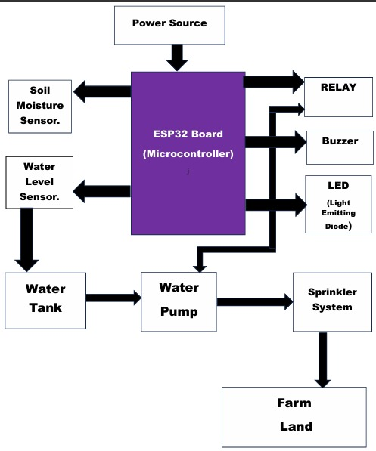
Fig3.1: Flow chart diagram of the project

3.2 Methodology
The project was implemented in three stages:
3.2.1 Automation Using Sensors
- Soil moisture and water-level sensors were connected to the ESP32.
- Control logic was written such that water would only be pumped when the soil was dry and the water tank had water above the required threshold.
- The system irrigates the soil until the moisture reading reaches the threshold, after which it is turned off.
3.2.2 Integration with Blynk Web Platform
- The ESP32 was connected to Wi-Fi and programmed to transmit sensor readings to the Blynk app.
- A real-time dashboard was created on Blynk to show soil moisture, water-level status, and pump activity.
- A manual control button was added on the app to allow the user to switch the pump ON/OFF remotely.
3.2.3 Machine Learning Component (Conceptual Extension)
- Historical soil moisture and irrigation data were logged for future analysis.
- A predictive model (e.g., regression or heuristic) was proposed to forecast when irrigation would be required, reducing reliance on fixed thresholds.
- This stage represents the move towards intelligence in the system, making irrigation adaptive and more resource-efficient.
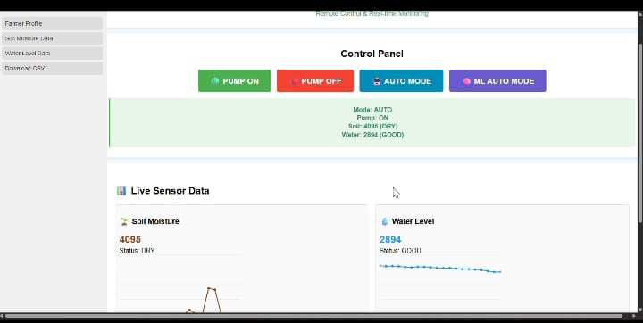
Fig3.2 : Blynk website
The hardware design consisted of soil moisture and water-level sensors, an ESP32 microcontroller, a relay module, and a 5V submersible pump. The soil moisture sensor provided analog voltage proportional to water content in the soil, while the water-level sensor detected tank levels. These inputs were processed by the ESP32, which applied control logic to activate the relay. When the soil was dry and the tank had water, the relay switched on the pump to irrigate the soil. Otherwise, the pump remained off. The ESP32 also connected via Wi-Fi to the Blynk platform, enabling real-time data visualization and manual override options for the user.
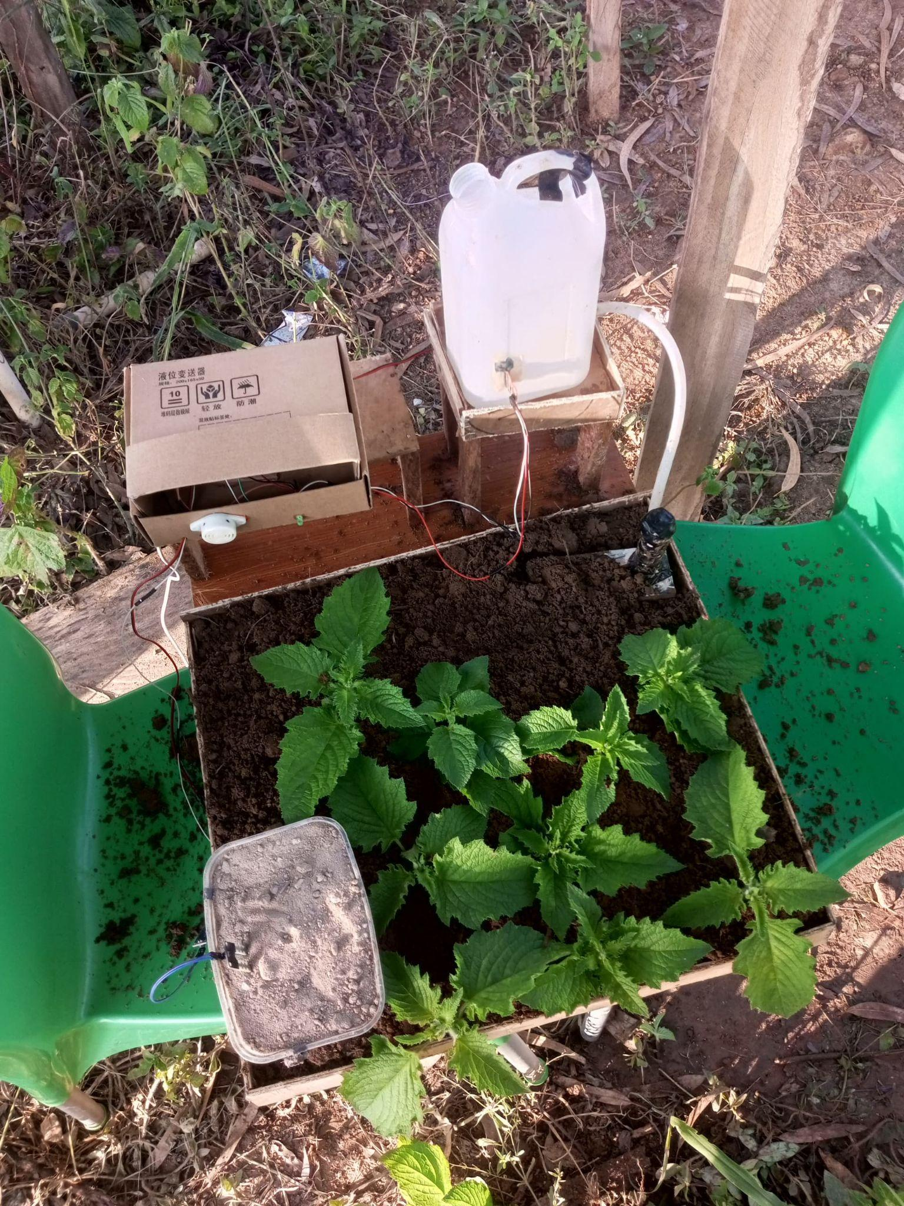
Fig 3.3: final project setup

4. RESULTS AND DISCUSSION
Prototype testing confirmed that the system could irrigate autonomously depending on soil moisture and water availability. From the moment the soil moisture went below the threshold, the pump would commence the process, stopping when the soil was sufficiently wet. In contrast, the Blynk dashboard reflected the changes in real time, allowing the user to observe or override the process. While quantitative efficacy data was not collected, the system functioned reliably in a controlled lab environment with proof of feasibility.

5. LIMITATIONS
Yet, despite its promise, the system suffered limitations. Low-cost sensors must surely be influenced by soil type, salinity, and temperature, requiring calibration for accuracy (Aguzzi et al., 2021). The prototype was tested on a small scale and would require more robust hardware for a large farm. The design also depended heavily on the availability of Wi-Fi, which could be considered untrustworthy in rural areas. Rainfall and environmental extreme conditions, among others, were not accounted for in the design. These problems therefore proposed that the next version should consider integration with weather APIs, solar, and advanced sensors.

6. CONCLUSION
This project demonstrated a functional intelligent irrigation system combining soil and water-level sensors with an ESP32 microcontroller and IoT connectivity. It successfully automated irrigation while offering remote monitoring, reducing manual effort and potential water waste. The system addresses key challenges in Nigerian agriculture by improving water management efficiency. While limited by sensor accuracy and scalability, it provides a foundation for further development towards a fully field-deployable intelligent irrigation solution.

References
- Aguzzi, J., et al. (2021). Designing low-cost capacitive-based soil moisture sensor and smart monitoring unit operated by solar cells for greenhouse irrigation management. Sensors, 21(12), 4036. https://doi.org/10.3390/s21124036
- Ahmed, Z., Gui, D., Murtaza, G., Yunfei, L., & Ali, S. (2023). An overview of smart irrigation management for improving water productivity under climate change in drylands. Agronomy, 13(8), 2113. https://doi.org/10.3390/agronomy13082113
- Archibong, E. A., Njok, A. O., & Osang, J. E. (2025). Smart irrigation in Nigeria: A panacea to curbing hunger and food insecurity. Asian Journal of Advanced Research and Reports, 19(6), 53–64. https://doi.org/10.9734/ajarr/2025/v19i61041
- Oussama, G., Rami, A., Tarek, F., Alanazi, A. S., & Abid, M. (2022). Fast and intelligent irrigation system based on WSN. Computational Intelligence and Neuroscience, 2022, Article 5086290. https://doi.org/10.1155/2022/5086290
- Rafi, M., & Handaga, B. (2021). Electronic device controller based on Internet of Things using ESP32 and Blynk (Undergraduate thesis). Universitas Muhammadiyah Surakarta. https://eprints.ums.ac.id/92273/
- Yahide, P. B., Jain, S. A., & Giri, M. (2015). Survey on web based intelligent irrigation system in wireless sensor network. Multidisciplinary Journal of Research in Engineering and Technology, 2(1), 375–385. https://mitpune.academia.edu/PrashantYahide

